

**Flap Actuator**

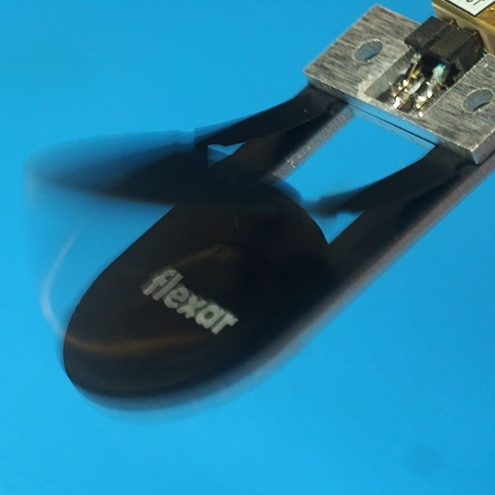

1. **Applications**

This thin actuator is perfect to create kinetic sculptures and experiment with robotics!

It comes assembled, with a 2.54mm pitch male connector and a 10mm N52 neodymium magnet on its back side. The actuator can be connected through the two M2 holes. The kit will also include double-sided [3M467](https://www.3m.com/3M/en_US/p/d/b40071696/) adhesive tape, which can be peeled off using a pair of tweezers and be mounted on the flap itself. This makes it easier to customize the flap, allowing it to actuate lightweight objects, like thin 3d-printed plastic models or paper-origami. Always clean the surface before sticking the tape.

To control the motion of this actuator, one must use an h-bridge module, like the [Flexar Driver](https://flexar.io/store/p/flexar-driver). The magnetic field strength of this coil is limited to 2.7mT (measured from the surface). Given that some aspects of this actuator are customizable, its motion and force will also depend on the magnet’s pivoting point and mass.

1. **Specifications**

|  |  |
| --- | --- |
| Minimum Estimated Lifetime (for long-use) | |
| 0.5Hz | +40 months |
| 1Hz | +20 months |
| 1.5Hz | +13 months |
| 2Hz | +10 months |
| 2.5Hz | +8 months |
| 3Hz | +7 months |
| 3.5Hz | +6 months |
| 4Hz | +5 months |
| 4.5Hz | +4 months |
| 5Hz | +4 months |

|  |  |
| --- | --- |
| Minimum Estimated Lifetime (for long-use) | |
| 5.5Hz | +4 months |
| 6Hz | +3 months |
| 6.5Hz | +3 months |
| 7Hz | +3 months |
| 7.5Hz | +3 months |
| 8Hz | +2 months |
| 8.5Hz | +2 months |
| 9Hz | +2 months |
| 9.5Hz | +2 months |
| 10Hz | +2 months |

This flap actuator can reach a speed up to 25Hz, but for but for long-use it is recommended not to exceed **10Hz**. The table below shows the safety-minimum estimated lifetime of the actuator.

*Higher limits are being tested, and will be updated in the coming future

Other specifications:

|  |  |
| --- | --- |
| PCB Specifications | |
| Dimensions | **34.31mm x 18.5mm** |
| Connector Pitch | **2.54mm** |
| Thickness | **1.4mm** |
| Weight | **2.6 grams** |
| Layers | **2** |
| Stiffener Material | **Aluminium** |
| Coverlay | **Black** |
| Silkscreen | **White** |
| Copper Thickness | **0.5oz** |

|  |  |
| --- | --- |
| Coil Specifications | |
| Track (Width/Pitch) | **4/4mil** |
| Turns | **70 turns** |
| Resistance | **24Ω ± 6** |
| Inductance | **25.3uH ± 1** |
| Maximum Constant Power* | **0.8W** |
| Maximum Operating Temperature | **100°C** |
| Peek Magnetic Field Strength | **2.7mT** |

|  |  |
| --- | --- |
| Magnet Specifications | |
| Dimensions | **10mm x 1mm** |
| Shape | **Disk** |
| Garde | **N52** |
| Weight | **0.6 grams** |
| Coating | **Nickel-Copper-Nickel** |
| Pull | **688 grams** |
| Vertical Hold | **137 grams** |
| Maximum Temperature | **80°C** |

*To determine the maximum constant driving voltage (100% duty cycle), one must measure the resistance of the coil and use the equation bellow:

$$V_{max}= \frac{R+10.96}{6.22}$$

This equation will ensure that the temperature of the PCB is kept under 100°C, which typically gives a voltage value between 4.5V to 5.4V. Driving the coil with higher voltages might damage the PCB. All voltage levels underneath this range are acceptable.

This constrain is a result of coil’s resistance tolerance (24Ω ± 6) as it can vary between different manufacturing batches, given that the track’s width and pitch are only 4/4mil.

1. **Testing**

*During these tests:*

* *All temperature readings were taken from the hottest point of the board*
* *All tesla readings were taken from the center of the coil*
* *Measurements were taken at room temperature (25°C)*
* *Measurements were taken at 100% Duty Cycle (Constant Voltage)*
* *Peek Magnetic Field is tested at the surface*

*Please note that by driving the coil with a constant voltage will increase its temperature. This will also increase the resistance and thus lower the current flowing through the coil. This effect can be resolved by controlling the coil with a constant current driver.*

1. **Drawing**

